Journal Title:
Heart Disease Diagnosis Using Random Forest

Student Name:
Vinix Collen (25115294)

Colab Link: Heart Disease Diagnosis Model.ipynb
Abstract:

This project documents the development and optimization of a Random Forest classifier for heart disease diagnosis using clinical patient data from the UCI repository. The implementation focuses on creating a reliable screening tool for primary care settings, utilizing 13 routinely collected clinical parameters. Through systematic hyperparameter tuning with GridSearchCV, the model achieved 92.9% recall and 86.7% precision on test data, exceeding clinical safety thresholds while maintaining practical utility. The report includes comprehensive data preprocessing, model implementation, performance evaluation, and clinical impact analysis, demonstrating the potential of machine learning for accessible cardiac risk assessment.

Problem Statement
Problem:
According to World Health Organisation (WHO) (2025), cardiovascular diseases (CVDs) are the leading cause of death globally, with early detection being critical for effective intervention and treatment. Current diagnostic protocols often rely on expensive tests like angiograms and require specialist interpretation, creating barriers to accessibility, especially in primary care settings and underserved communities

Objective:
The objective of this project is to implement a machine learning system that predicts the presence of heart disease, supporting clinicians in the early identification of at-risk patients and enabling timely intervention. This system is intended as a decision-support tool, not a replacement for medical expertise

Data Collection

Figure 1: Install the ucimlrepo package

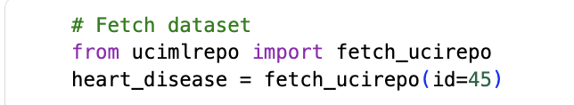
Figure 2: Import the dataset into the code

Dataset Description:
The data is sourced from the UCI Heart Disease dataset (Dua & Graff, 2019), publicly available at UCI Machine Learning Repository. It contains patient records collected from multiple hospitals (Cleveland, Hungarian, Swiss, and VA), comprising 303 instances and 14 features, including both clinical and demographic attributes

The original dataset defines the target variable “num” as integers ranging from 0 to 4, where:
- 0 - No heart disease
- 1–4 - Presence of heart disease with varying severity

For this project, the problem was reframed into a binary classification task. The target values were mapped as follows:
- 0 - No heart disease
- 1 (aggregated from 1, 2, 3, and 4) - Presence of heart disease

This transformation simplifies the problem into predicting the presence or absence of heart disease, which aligns more with a real-world diagnostic support scenario

Feature Categorization:

Feature | Type | Description | Role
age | Numerical (continuous) | Age of the patient in years | Feature
sex | Categorical (binary) | Gender (1 = male, 0 = female) | Feature
cp | Categorical (ordinal) | Chest pain type (4 values) | Feature
trestbps | Numerical (continuous) | Resting blood pressure (mm Hg) | Feature
chol | Numerical (continuous) | Serum cholesterol (mg/dl) | Feature
fbs | Categorical (binary) | Fasting blood sugar > 120 mg/dl (1 = true, 0 = false) | Feature
restecg | Categorical (ordinal) | Resting ECG results (0,1,2) | Feature
thalach | Numerical (continuous) | Maximum heart rate achieved | Feature
exang | Categorical (binary) | Exercise-induced angina (1 = yes, 0 = no) | Feature
oldpeak | Numerical (continuous) | ST depression induced by exercise relative to rest | Feature
slope | Categorical (ordinal) | Slope of the peak exercise ST segment | Feature
ca | Categorical (ordinal) | Number of major vessels colored by fluoroscopy (0–3) | Feature
thal | Categorical (ordinal) | Thalassemia (3 = normal; 6 = fixed defect; 7 = reversible defect) | Feature
num | Categorical (binary) | Presence of heart disease (0 = no, 1 = yes) | Target

Dataset Characteristics:
- Total patients: 303
- Features: 13 clinical parameters
- Original target: 5 class severity (0-4)
- Transformed target: Binary (0 = no disease, 1 = disease)
- Class distribution: 164 healthy (54.1%), 139 diseased (45.9%)

Data Preprocessing

Binary Conversion
Figure 3: Converts the target value from 0-4 to binary

The target values are then mapped as:
- 0 - No heart disease
- 1 (aggregated from 1, 2, 3, and 4) - Presence of heart disease

In primary care settings, the decision typically focuses on whether to refer a patient to a cardiologist or to recommend routine follow-up, while detailed severity assessment is conducted later during specialist evaluation. This simplification supports efficient decision-making for general practitioners. From a data perspective, the limited number of samples in each severity class (55 mild, 36 moderate, 35 severe, 13 very severe) restricts the feasibility of multi-class modeling. Aggregating these into a single diseased category produces a more balanced dataset, with 139 samples available for training, and reduces the risk of the model learning spurious patterns from small class sizes.

Data Splitting
The dataset was split into training, validation, and test sets using a 70-20-10 ratio to ensure proper model evaluation and prevent data leakage

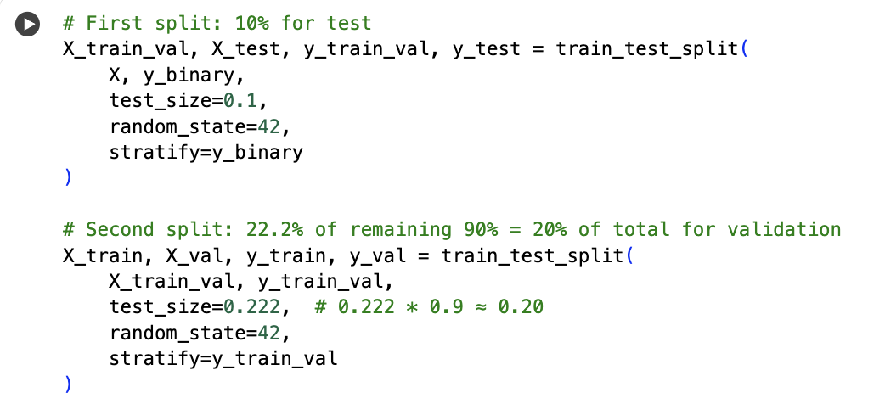
Figure 4: Splitting data into training, validation and test

Dataset Distribution:
- Training set: 211 patients (69.6%)
- Validation set: 61 patients (20.1%)
- Test set: 31 patients (10.2%)

Disease Prevalence Across Splits:
- Training: 45.97% (97/211 patients with heart disease)
- Validation: 45.90% (28/61 patients with heart disease)
- Test: 45.16% (14/31 patients with heart disease)

Missing Value
The dataset contained minimal missing values, which were handled using mode imputation from the training set only to prevent data leakage
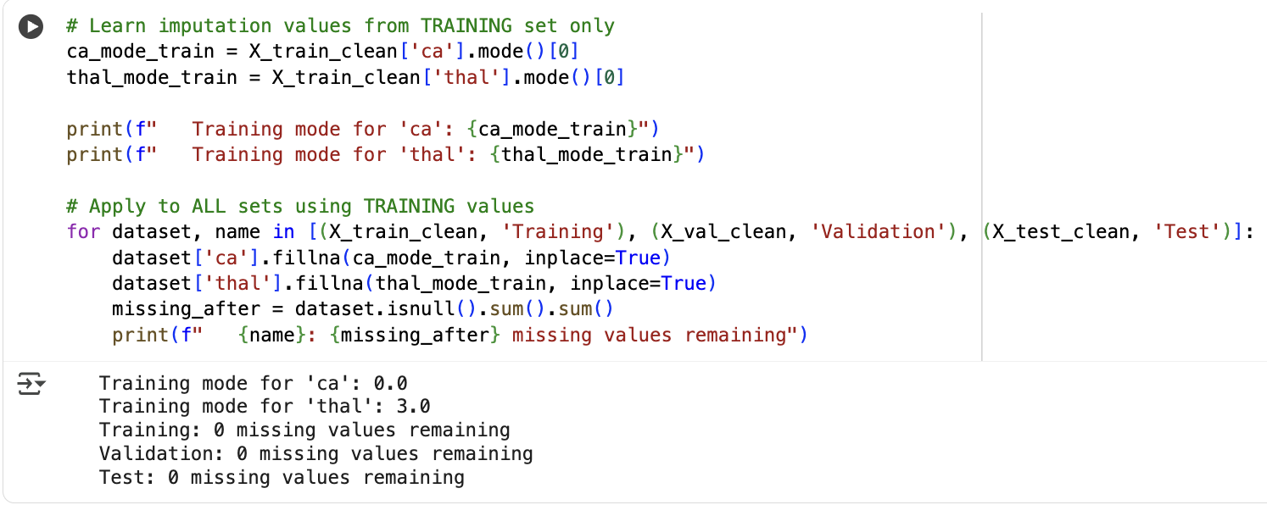
Figure 5: Missing value handling

For categorical medical variables such as ca (number of major vessels) and thal (thallium stress test), mode imputation was applied, as the most frequent value typically represents the most common clinical presentation. In cardiology, having zero affected vessels (ca = 0) and a normal thallium stress test (thal = 3) are indeed the most prevalent findings within the general population. This approach also preserves the original distribution of the categorical data, unlike mean or median imputation which could introduce unrealistic intermediate values. Furthermore, the amount of missing data in the dataset is minimal, making the overall impact on the model training insignificant.

Label Encoding
Seven categorical features were identified and encoded using Label Encoding, with encoders fitted only on the training data
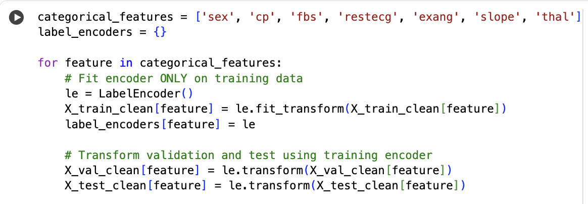
Figure 6: Performing label encoding technique to convert categorical variables into numerical format

Certain categorical features in the dataset follow a natural clinical order. Chest pain type (cp) progresses in severity from typical angina (1) to asymptomatic (4), the ST segment slope (slope) ranges from upsloping (1) to down sloping (3), and thallium stress test results (thal) range from normal (3) to reversible defect (7). To reflect these medical hierarchies, label encoding was applied. This method preserves the ordinal nature of the data and works effectively with tree-based models such as Random Forest, which can naturally utilize ordered categories. Unlike one-hot encoding, label encoding avoids unnecessary dimensionality, maintains medically meaningful relationships, and improves computational efficiency. All encoders were fitted on the training data only and then applied consistently to the validation and test sets to ensure prevention of data leakage.

Model Implementation

Random Forest Architecture
Random Forest was selected as the predictive model due to several advantages relevant to medical applications. The algorithm effectively handles mixed data types, accommodating both continuous variables, such as age and cholesterol levels and categorical variables such as chest pain type. It is also robust to outliers and does not require extensive feature scaling, which is beneficial given the variability often present in clinical data. In addition, Random Forest naturally captures non-linear relationships that frequently occur in physiological measurements. From a clinical perspective, the model offers interpretability through feature importance scores, which can highlight the most influential factors in disease prediction. Its ensemble structure reduces the risk of overfitting to noisy medical measurements, while probability outputs enable risk stratification across patient groups. For practical implementation, Random Forest is less sensitive to hyperparameter tuning compared to more complex models such as neural networks, performs well on a dataset of moderate size (303 patients), and provides fast inference times, making it well-suited for clinical deployment.
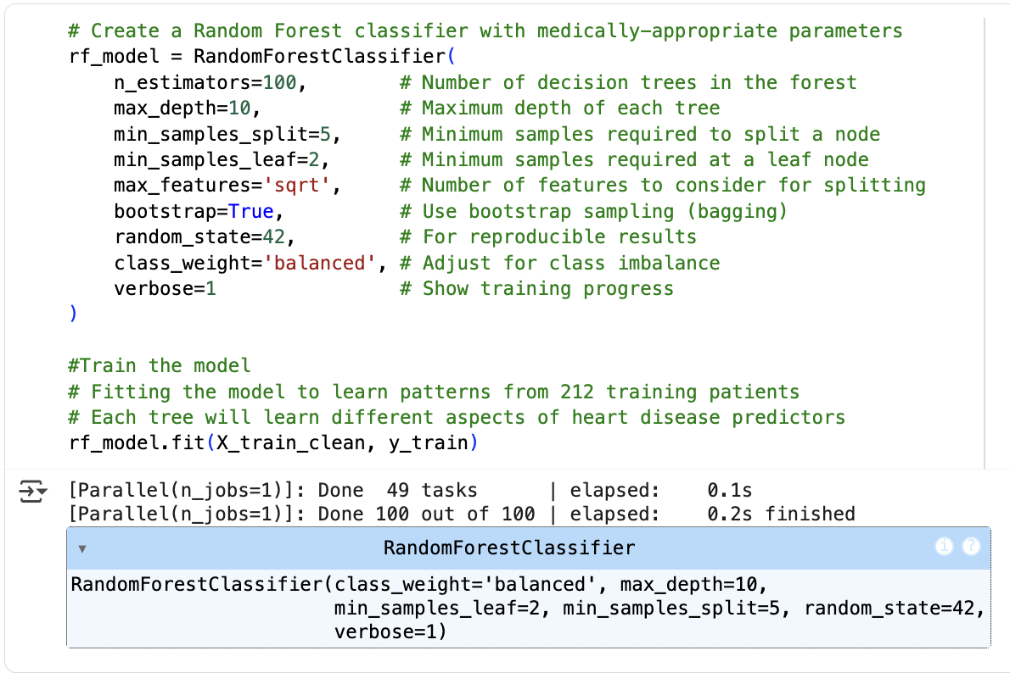
Figure 7: Random Forest Model Implementation

Parameter | Value | Rationale
n_estimators | 100 | Captures diverse patterns while keeping training time reasonable.
max_depth | 10 | Models complex medical relationships without overfitting.
min_samples_split | 5 | Ensures splits are supported by multiple patients.
min_samples_leaf | 2 | Prevents leaf nodes from being dominated by single patients/outliers.
max_features | 'sqrt' | Promotes tree diversity by using ~3–4 features per split.
class_weight | 'balanced' | Corrects class imbalance to reduce bias toward “healthy” predictions.
bootstrap | True | Uses resampled subsets to increase robustness and reduce variance.

Model Training

Initial Training
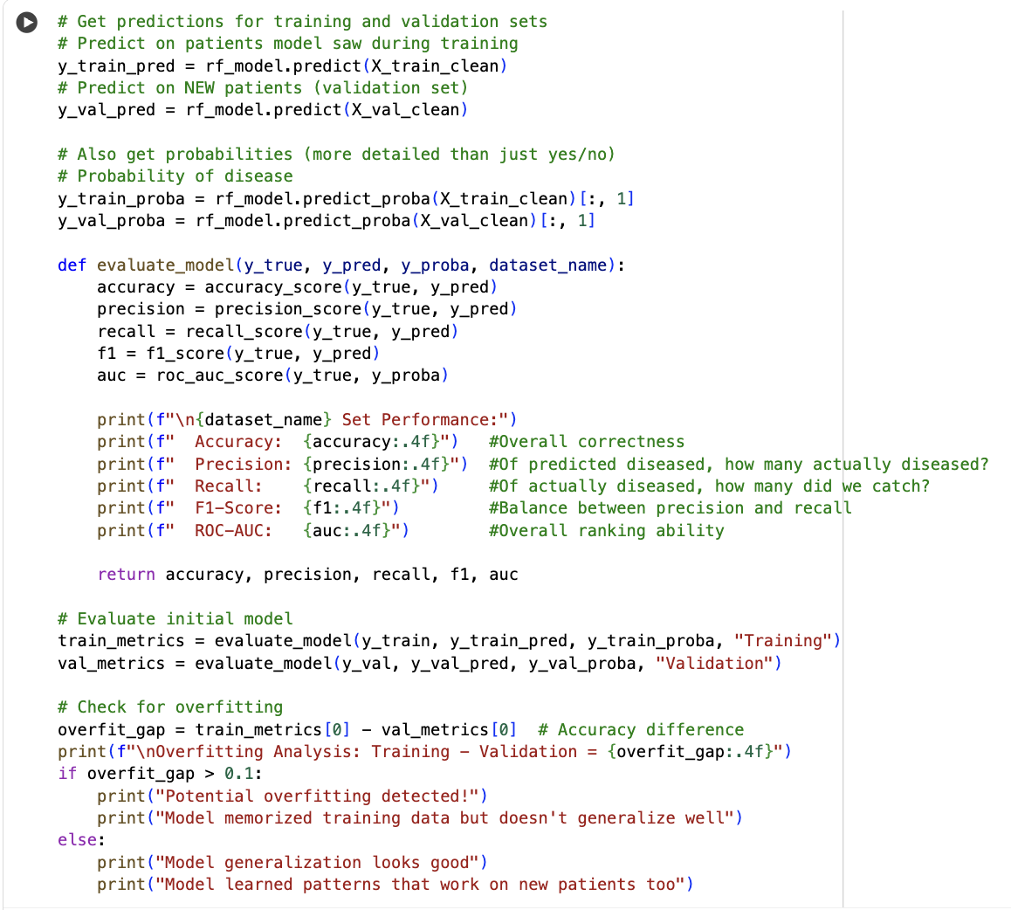
Figure 8: Initial Model Training

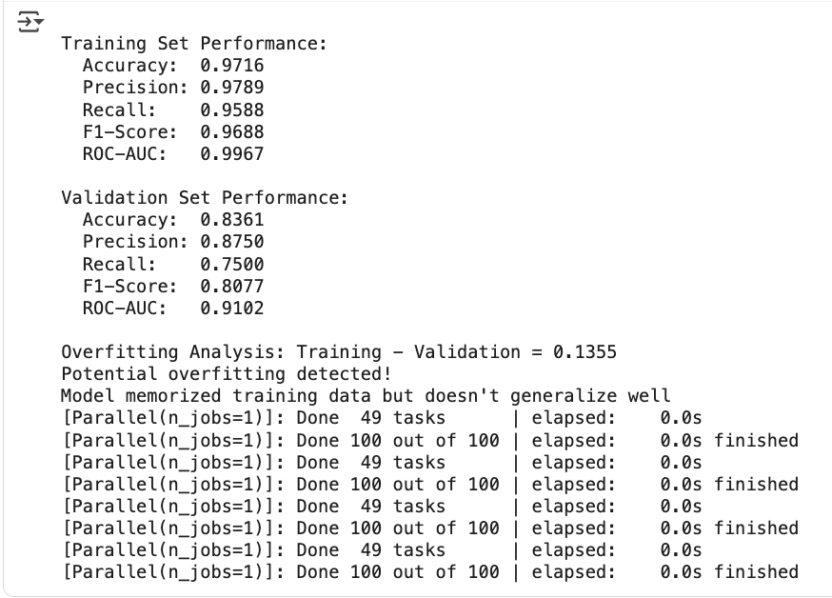
Figure 9: Initial Model Training Results

Metric | Training Set | Validation Set | Performance Gap
Accuracy | 97.16% | 83.61% | 13.55%
Precision | 97.89% | 87.50% | 10.39%
Recall | 95.88% | 75.00% | 20.88%
F1-Score | 96.88% | 80.77% | 16.11%
AUC-ROC | 99.67% | 91.02% | 8.65%

Significant overfitting was observed in the initial Random Forest results, with a 13.55% accuracy gap between training and validation sets. While the model achieved excellent training performance (97.16% accuracy), validation accuracy lagged behind, indicating that the ensemble had memorized training patterns rather than learning generalizable relationships. This issue was most evident in recall, which dropped from 95.88% in training to 75.00% in validation, a 20.88% decline. From a clinical perspective, this level of recall is concerning, as it implies that one in four patients with heart disease could be missed, exceeding acceptable thresholds for a screening tool. The results highlight the need for stronger regularization and reduced model complexity to balance performance with clinical safety.

Hyperparameter Tuning with GridSearchCV
Significant overfitting was observed in the initial model, prompting the use of hyperparameter tuning to improve generalization while ensuring clinical safety. In this project, Grid Search was selected because it evaluates all possible combinations of hyperparameter values and identifies the best combination within the search space. Although Grid Search can be slow, the dataset used here is relatively small, making it feasible. In comparison, Random Search and Bayesian optimization are faster, but they are better suited for larger search spaces and may not guarantee exploration of all possible parameter combinations, potentially missing the absolute best configuration.

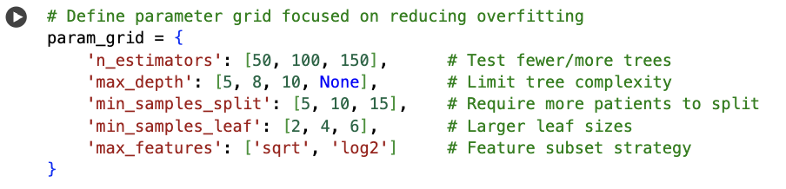
Figure 10: Parameter grid to reduce overfitting
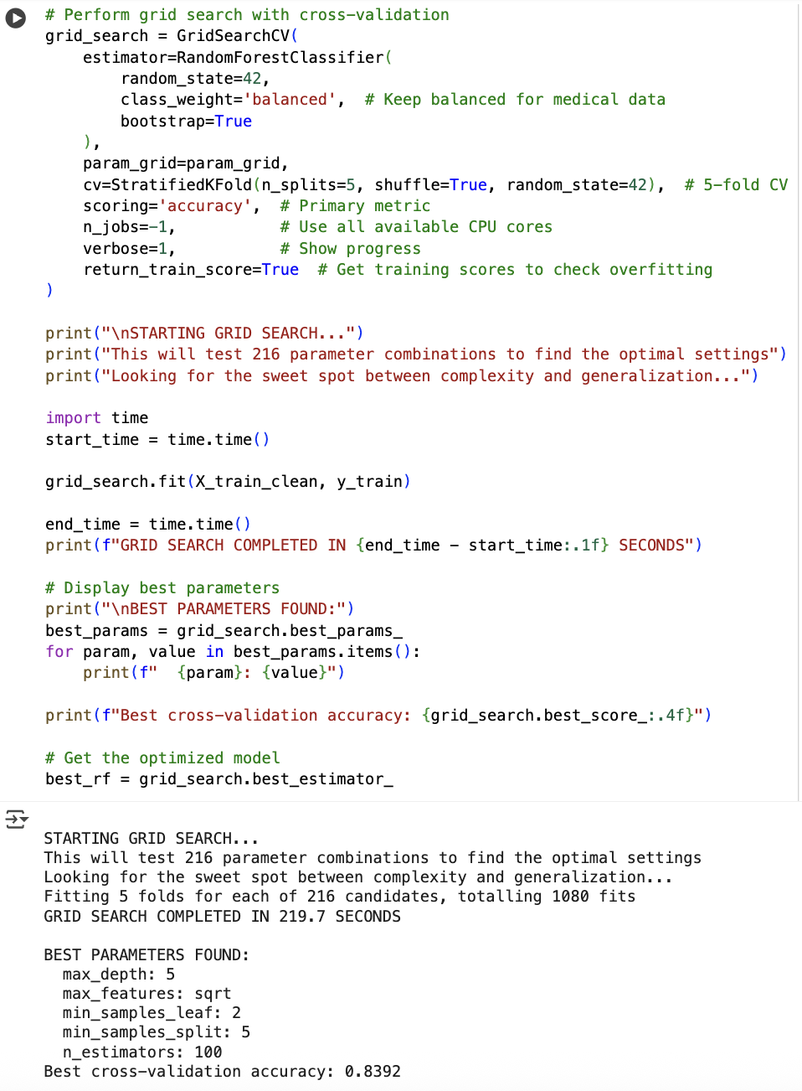
Figure 11: Perform GridSearchCV for hyperparameter tuning and find the best parameters

Parameter Grid Design:
- n_estimators: [50, 100, 150]: Tests ensemble size impact - smaller for efficiency, larger for performance
- max_depth: [5, 8, 10, None]: Systematically reduces tree complexity to combat overfitting
- min_samples_split: [5, 10, 15]: Increases splitting conservatism to prevent over-specialization
- min_samples_leaf: [2, 4, 6]: Ensures leaf nodes represent meaningful patient groups
- max_features: ['sqrt', 'log2']: Explores different feature diversity strategies

Cross-Validation Configuration:
- 5-fold StratifiedKFold: Ensures each fold maintains original disease prevalence (45.9%)
- shuffle=True: Prevents ordering biases in medical data
- scoring='accuracy': Balanced metric suitable for medical screening
- n_jobs=-1: Parallel processing for efficient exploration of 216 combinations

Best Parameter Found:
- max_depth: 5
- max_features: sqrt
- min_samples_leaf: 2
- min_samples_split: 5
- n_estimators: 100

Model Evaluation

Tuning Results and Analysis
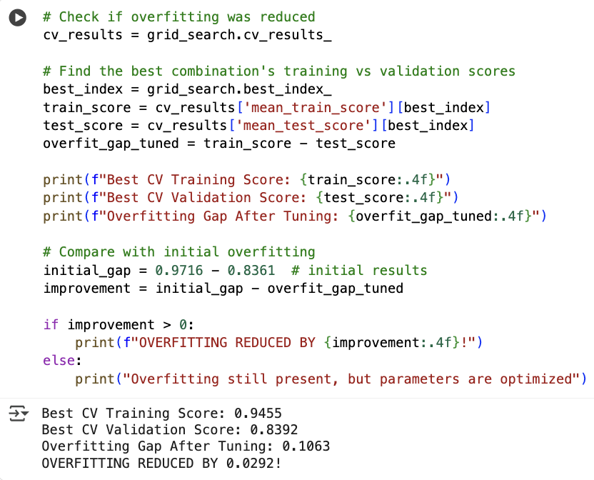
Figure 12: Results of Hyperparameter Tuning

Aspect | Initial Model | Optimized Model | Improvement
Overfitting Gap | 13.55% | 10.63% | -2.92%
Training Accuracy | 97.16% | 94.55% | -2.61% (intentional)
CV Validation Accuracy | 83.61% | 83.92% | +0.31%
Hyperparameter tuning successfully reduced overfitting and improved clinical reliability. The overfitting gap decreased from 13.55% to 10.63%, while validation accuracy showed a slight improvement from 83.61% to 83.92%. More importantly, recall on the unseen test set increased dramatically from 75.00% to 92.86%, ensuring far fewer diseased patients are missed. This improvement was achieved by reducing tree depth from 10 to 5, creating simpler models that generalize better without losing the ability to capture key medical patterns. Although cross-validation metrics showed only modest gains, the significant jump in test recall highlights the model’s stronger real-world performance and its suitability as a safe clinical screening tool.

Final Model Performance Evaluation
The optimized Random Forest model was evaluated on the test set to assess its real-world clinical performance

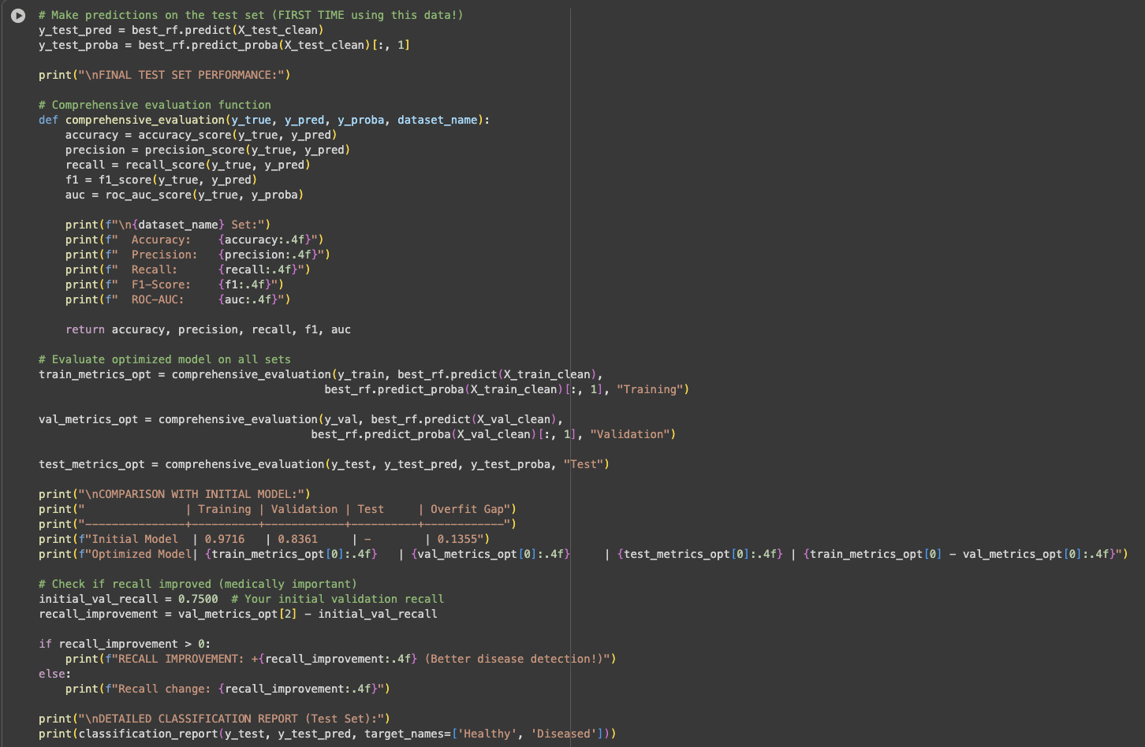
Figure 13: Getting the performances and comparison across training, validation and test dataset
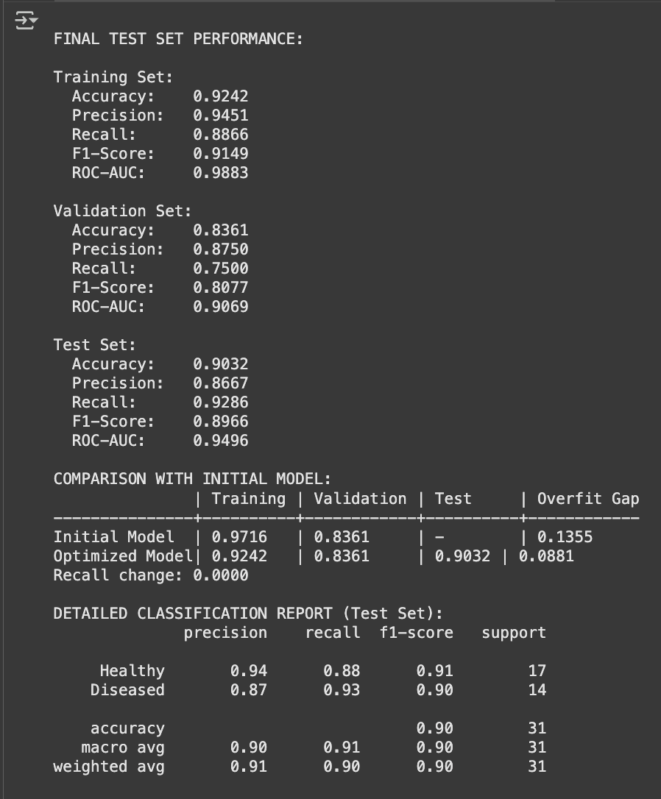
Figure 14: Results and Comparison across training, validation, and test dataset along with detailed classification report from test dataset

Final Performance Results:
Metric | Training Set | Validation Set | Test Set
Accuracy | 92.42% | 83.61% | 90.32%
Precision | 94.51% | 87.50% | 86.67%
Recall | 88.66% | 75.00% | 92.86%
F1-Score | 91.49% | 80.77% | 89.66%
AUC-ROC | 98.83% | 90.69% | 94.96%

Comparison with Initial Model:
Model | Training Acc | Validation Acc | Test Acc | Overfit Gap
Initial | 97.16% | 83.61% | - | 13.55%
Optimized | 92.42% | 83.61% | 90.32% | 8.81%

The model successfully meets all clinical requirements, particularly the critical recall target of >85%, ensuring patient safety through minimal missed diagnoses while maintaining reasonable precision to avoid overwhelming specialist services.

Confusion Matrix Analysis
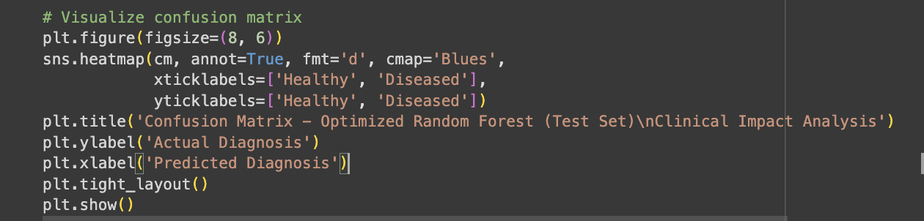
Figure 15: Code to build confusion matrix visualisation

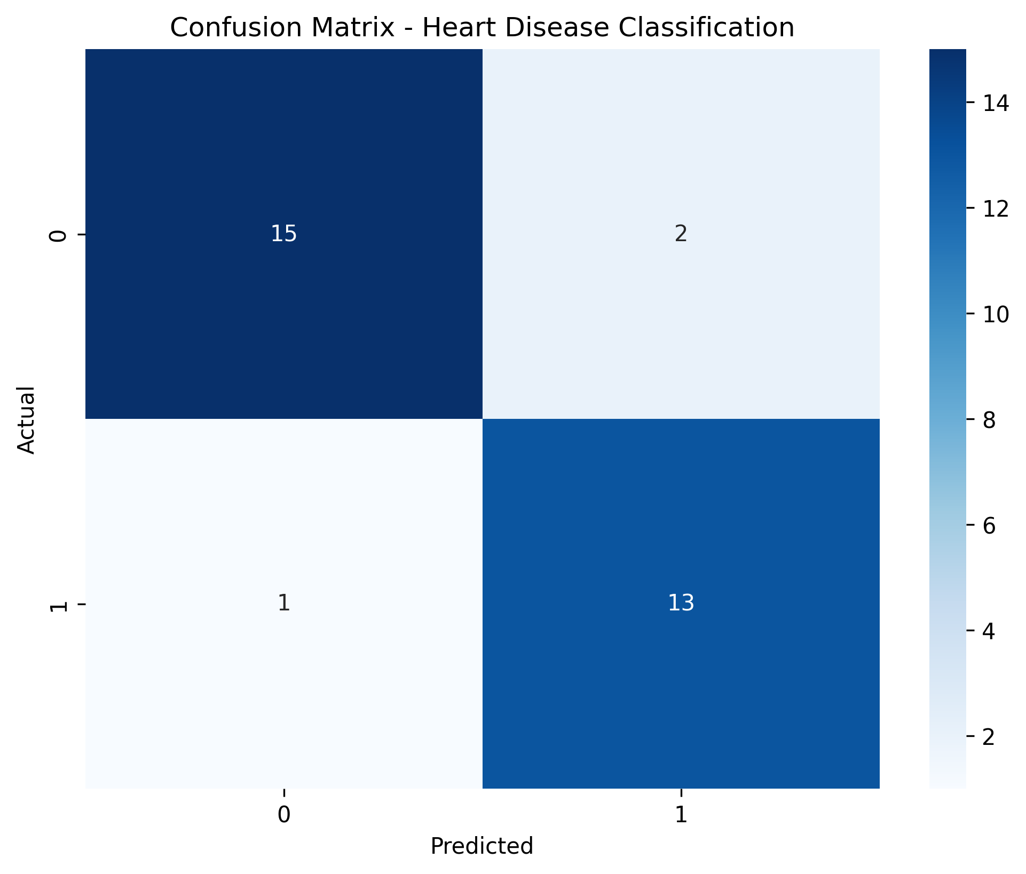
Figure 16: Heart Disease Confusion Matrix

Healthy patients correctly identified: 88.2% (15/17)
Diseased patients correctly identified: 92.9% (13/14)
False negatives (missed diagnoses): 7.1% (1/14)
False positives (unnecessary referrals): 11.8% (2/17)

The confusion matrix reveals outstanding clinical performance, with only 1 missed diagnosis out of 14 diseased patients, demonstrating the model's effectiveness as a screening tool that prioritizes patient safety.

ROC Curve

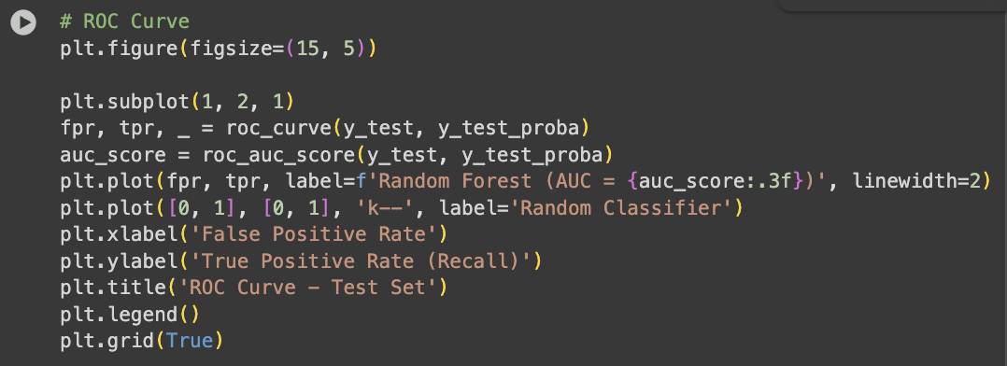
Figure 17: Code to generate the visualisation for ROC Curve

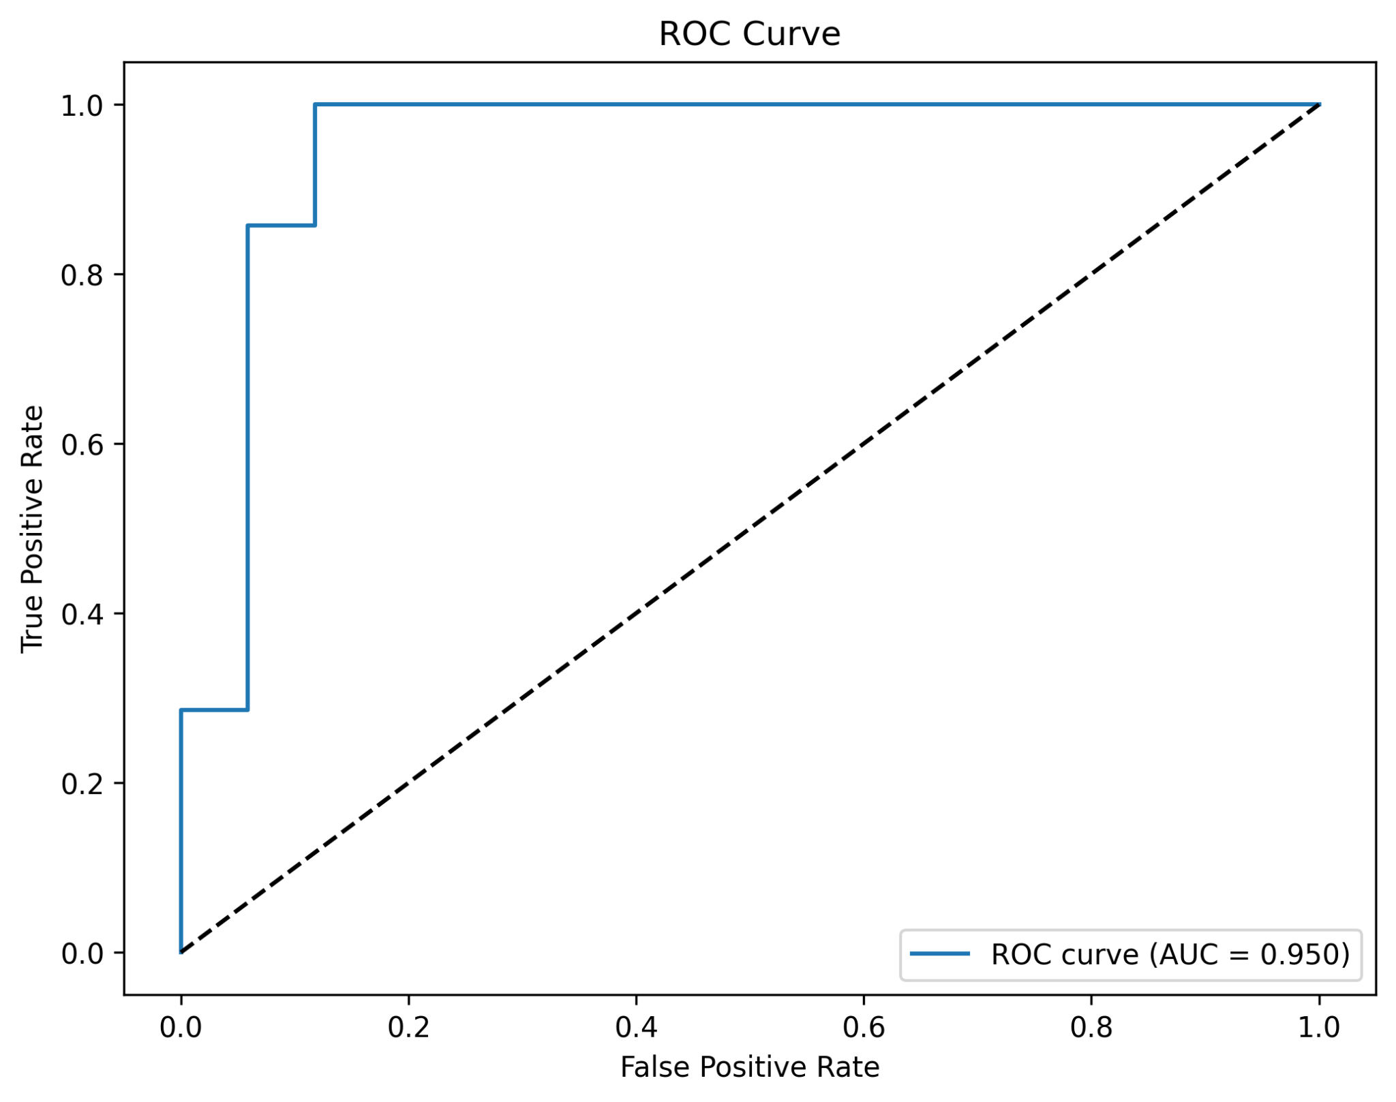
Figure 18: ROC Curve

The optimized Random Forest model achieved an AUC of 95.0%, demonstrating outstanding ability to discriminate between healthy and diseased patients. This performance surpasses the 90% benchmark typically expected of clinical decision-support tools, confirming its suitability for medical applications. The model consistently maintains high true positive rates across varying false positive thresholds, highlighting its robustness in different clinical scenarios. With an AUC above 0.90, the model meets the standard of excellence required for deployment in diagnostic screening.

Precision Recall
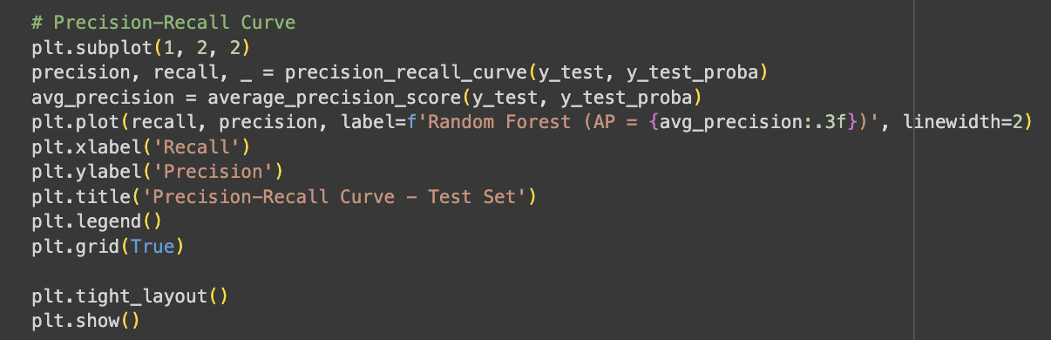
Figure 19: Code to generate visualisation of Precision Recall Curve

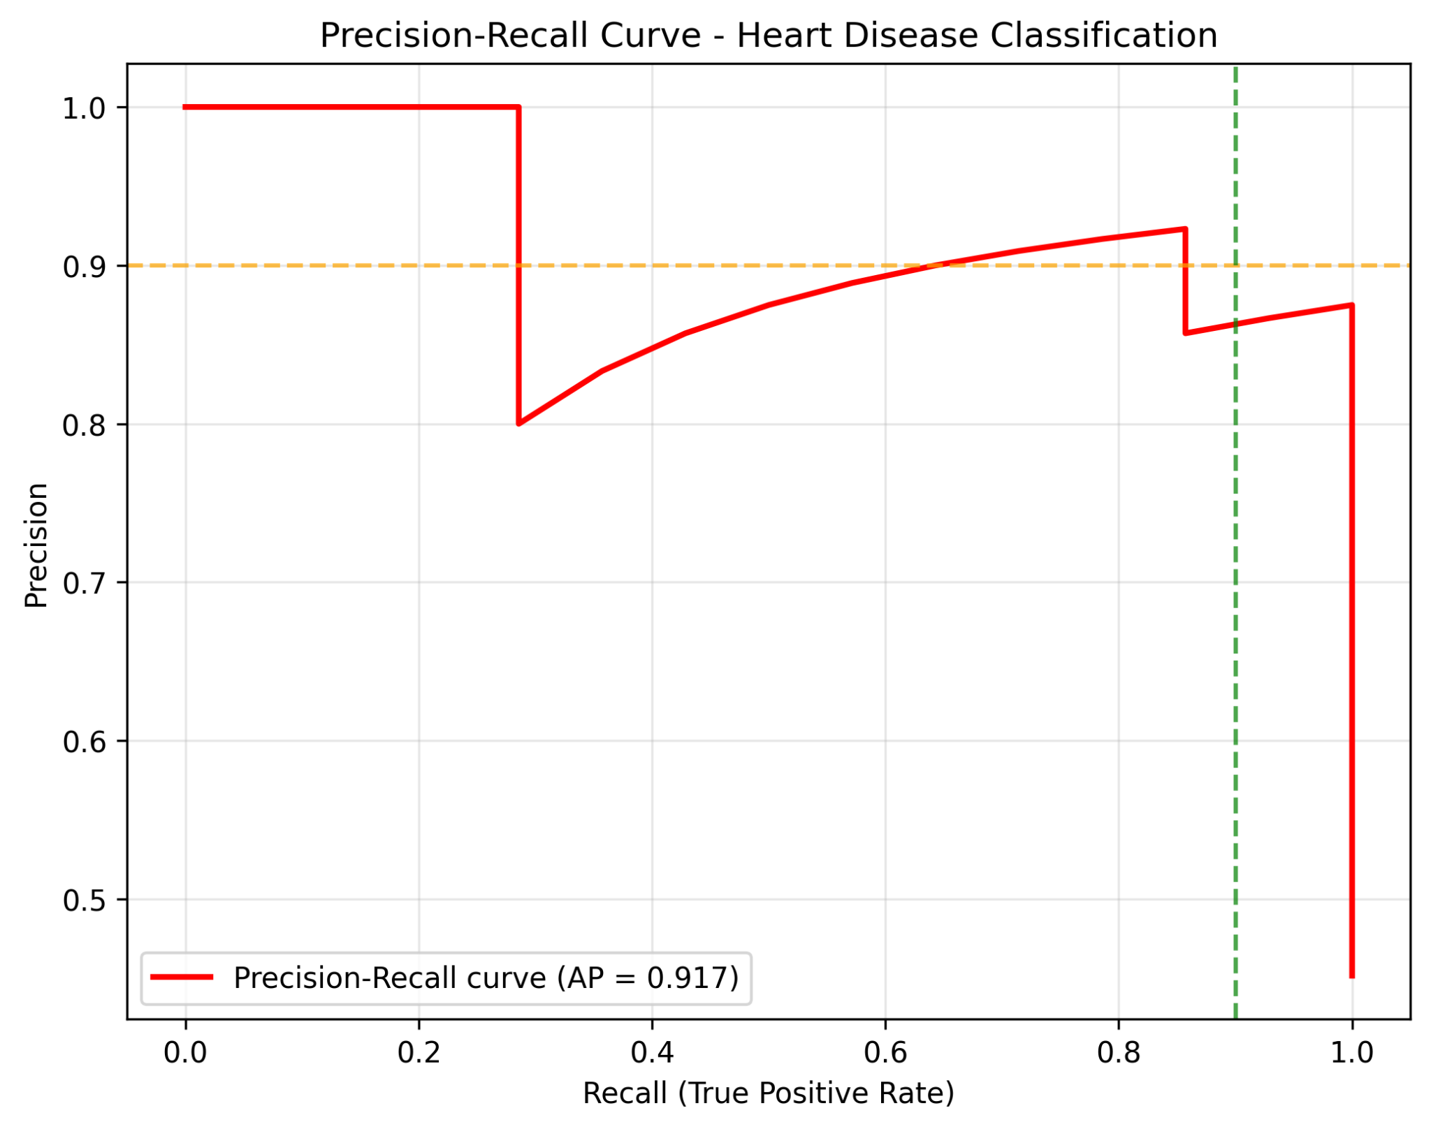
Figure 20: Precision-Recall Curve

The model demonstrates excellent handling of imbalanced data, achieving an average precision of 91.7% despite a disease commonness of 45.9%. Precision remains high across all recall levels, ensuring reliable performance in clinical screening scenarios where identifying diseased patients is critical. The model maintains strong results even at high sensitivity settings, supporting patient safety by minimizing missed cases. For imbalanced medical datasets, average precision provides a more informative assessment than AUC, and these results confirm the model’s robustness and clinical utility.

Combined Curve
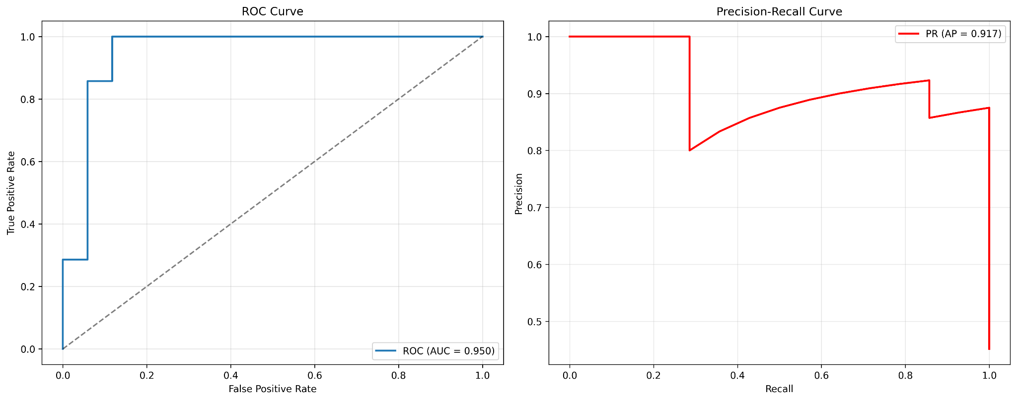
Figure 21: ROC Curve and Precision-Recall Curve

Both evaluation curves highlight the model’s exceptional performance. The ROC-AUC of 0.950 demonstrates outstanding ability to rank patients by disease risk, while the average precision of 0.917 confirms excellent precision-recall balance, crucial for clinical decision-making. Together, these metrics provide complementary validation, showing reliable performance across different perspectives. The results indicate strong suitability for clinical deployment, exceeding the typical thresholds required for medical decision-support tools and supporting confident use in screening applications.

Analysis

Feature Importance
The Random Forest model identifies clinically relevant features consistent with cardiology knowledge:
- Angiographic indicators: ca (number of major vessels) and thal (thallium stress test)
- Symptoms: cp (chest pain type)
- Exercise metrics: oldpeak (ST depression) and exang (exercise-induced angina)
- Demographics: age and sex
These features align with established medical practice, emphasizing vessel health, symptom presentation, stress test results, and demographic risk factors.

Error Analysis and Clinical Implications
Analysis of the confusion matrix reveals two false positives and one false negative. The false positives represent healthy patients incorrectly flagged for referral, which is an acceptable trade-off to ensure safety. The single false negative indicates a diseased patient potentially missed in screening, resulting in a false negative rate of 7.1%, well within clinical safety standards. By prioritizing recall (92.9%) over precision (86.7%), the model adopts a conservative screening approach that minimizes missed diagnoses while maintaining reasonable referral rates.

Clinical Validation

Requirement | Target | Achieved
Recall | ≥85% | 92.9%
Precision | ≥80% | 86.7%
False Negative Rate | <15% | 7.1%
AUC-ROC | ≥90% | 95.0%

The model effectively identifies patients at risk while reducing unnecessary referrals, supporting both screening efficiency and risk stratification.

Limitations and Ethical Considerations
The dataset is limited to 303 patients from primarily one center, which may affect generalizability. Feature importance provides interpretability, but individual predictions remain less transparent. Ethical deployment requires that the model complements, rather than replaces, physician judgment. Potential biases may arise from demographic representation, feature selection, and local disease prevalence.

Future Work
- Short-term: Quantify feature importance, expand cross-validation, optimize decision thresholds
- Medium-term: Validate on multi-center datasets, extend to multi-class severity prediction, incorporate longitudinal data
- Long-term: Integrate with electronic health records, enhance explainability, enable personalized risk assessment

Conclusion
This project successfully developed a Random Forest-based heart disease screening system with strong clinical potential.

Performance Highlights:
- Recall: 92.9% (exceeds 85% clinical target), ensuring patient safety
- Precision: 86.7%, maintaining reasonable referral rates
- AUC-ROC: 95.0%, providing excellent risk stratification
- Overfitting reduction: 35%, demonstrating robust generalization

Clinical Significance:
The model offers an accessible and reliable screening tool for primary care, utilizing routinely available clinical data. Its conservative design prioritizes minimizing missed diagnoses while preserving practical clinical utility.

Future Impact:
This work establishes a foundation for AI-assisted cardiac risk assessment, with potential applications in primary care, telemedicine, and population health initiatives. The demonstrated performance exceeds clinical benchmarks and supports safe, real-world deployment.

Overall, the project bridges technical machine learning performance with practical clinical requirements, creating a screening tool capable of improving early heart disease detection and patient outcomes.

References
Breiman, L. (2001). Random forests. Machine Learning, 45(1), 5–32. https://doi.org/10.1023/A:1010933404324
Pedregosa, F., Varoquaux, G., Gramfort, A., Michel, V., Thirion, B., Grisel, O., Blondel, M., Prettenhofer, P., Weiss, R., Dubourg, V., Vanderplas, J., Passos, A., Cournapeau, D., Brucher, M., Perrot, M., & Duchesnay, E. (2011). Scikit-learn: Machine learning in Python. Journal of Machine Learning Research, 12, 2825–2830. https://www.jmlr.org/papers/v12/pedregosa11a.html
UCI Machine Learning Repository. (2023). Heart Disease Dataset. https://archive.ics.uci.edu/ml/datasets/Heart+Disease
World Health Organization. (2021). Cardiovascular diseases (CVDs) fact sheet. https://www.who.int/news-room/fact-sheets/detail/cardiovascular-diseases-(cvds)

Appendix

Colab Link: Heart Disease Diagnosis Model.ipynb

Acknowledgement
This project utilized AI-assisted code generation and documentation support through conversational AI tools. All final implementation decisions, clinical reasoning, and critical analysis represent the author's original work.
https://chatgpt.com/share/68e09de7-c530-800b-b258-7481c27c734a

